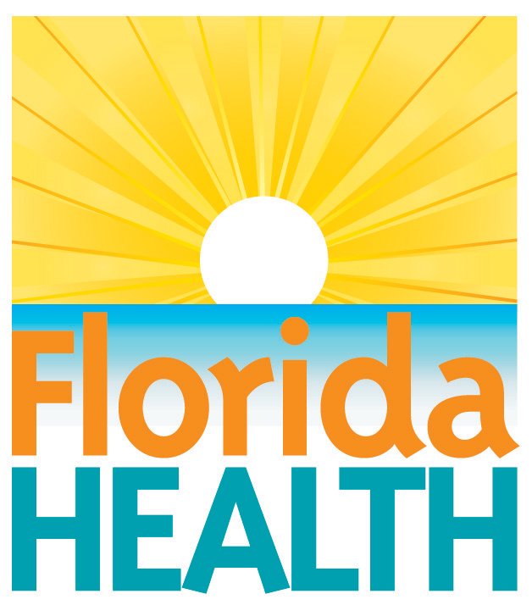
Feb. 2, 2016

department reports six new

travel-associated zika cases to the cdc
Contact:
Communications Office
NewsMedia@flhealth.gov
850-245-4111
Tallahassee, Fla. – This week, the Florida Department of Health reported six new travel-associated cases of Zika in Florida to the Center for Disease Control and Prevention (CDC). Travel-related cases are defined as disease believed to be contracted outside of the state. Florida has reported a total of nine travel-related cases to the federal government.
While the CDC has not identified Florida as an area of local Zika risk, the Florida Department of Health is closely monitoring imported disease. None of the confirmed cases involve pregnant women. Yesterday, Governor Rick Scott and State Surgeon General and Secretary of Health Dr. John Armstrong were briefed by the CDC on the status of Zika virus.
The CDC has issued travel notices for Zika virus for several countries. More information about the CDC’s notices can be found here: http://wwwnc.cdc.gov/travel/notices.
“Florida has many years of success in containing other mosquito-borne diseases and emerging health threats,” said State Surgeon General and Secretary of Health. “Through these experiences, the department remains ready to protect residents and visitors from the Zika virus.”
More Information on CDC precautions and DOH monitoring of Zika:
- According to the CDC, Zika fever illness is generally mild with a rash, fever and joint pain. CDC researchers are examining a possible link between the virus and unborn babies exposed during pregnancy.
- Florida’s public health laboratory has a developed capacity to test for infections. The department works closely with health care providers in the state to offer testing to individuals that meet CDC testing criteria.
- DOH has a robust mosquito-borne illness surveillance system and is working with the CDC, the Florida Department of Agriculture and Consumer Services and local county mosquito control boards to ensure that the proper precautions are being taken to protect Florida residents and visitors.
- DOH encourages Florida residents and visitors to protect themselves from all mosquito-borne illnesses by draining standing water; covering their skin with repellent and clothing; covering windows with screens; and other basic precautions.
- To date, Florida has confirmed nine travel-associated cases, which involve residents from the following counties:
  - Miami-Dade – 4 cases
  - Hillsborough – 2 cases
  - Lee – 2 cases
  - Santa Rosa – 1 case
- The department has a PSA video that media partners are welcome to share regarding “Drain and Cover” and preventing mosquito bites. The video can be accessed here: https://www.youtube.com/watch?v=AE6tkoWanXk
For more information on Zika virus, click here.
About the Florida Department of Health
The department works to protect, promote and improve the health of all people in Florida through integrated state, county and community efforts.
Follow us on Twitter at @HealthyFla and on Facebook. For more information about the Florida Department of Health please visit www.FloridaHealth.gov.

